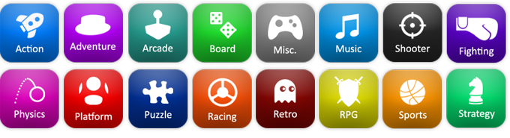

Level 3 Creative Digital Media Production (Games Development)

**Unit 13:** Digital Games Production

|  |  |  |
| --- | --- | --- |
| **Qualification** | | [Qualification] |
| **Unit number and title** | | **Unit 13: Digital Games Production** |
| **Learning aim(s)** | | **C:** Produce and check a digital game in a specific genre. |
| **Assignment title** | | Creating your digital game |
| **Assessor** | | [Assessor Name] |
| **Issue date** | | 20/03/18 |
| **Hand in deadline** | | **22/05/18** |
| **Criteria covered by this task:** | | |
| Unit/Criteria reference | To achieve the criteria you must show that you are able to: | |
| **Unit 13/A.D3** | Create a digital game in a specific genre, justifying the level of challenge for the target audience. | |
| **Unit 13/A.M4** | Create a digital game in which the genre features have been effectively used to target the audience. | |
| **Unit 13/A.M5** | Assess the strengths and weaknesses of the finished digital game. | |
| **Unit 13/A.P5** | Create a digital game that demonstrates features of the chosen genre | |
| **Unit 13/A.P6** | Explain how the functionality of the digital game has been checked. | |
|  | | |
| **Vocational Scenario or Context** | | You have just received an invite to the ‘Epic Games Contest”. The objective of this Game Jam is to create a game in Unreal Engine 4. The ideas for the games are down to you and the most imaginative game will win.  This completion will not only test your ability to create games but also your ability to design them looking at the genre and features. |
| **Task 2** | | For this task, you are a required to demonstrate your ability to create a tutorial level based on your design documentation previously submitted.  You will need to **build your game level** making sure to include the following;   * **The development of the game itself**   + Assets (importing, settings, naming conventions)   + Initial set up (room size, indoor/outdoor etc…)   + Set up of graphics (textures/materials)   + Set up of animation (level sequencer)   + Layout to fit with chosen genre   + Construction of goals, challenges and rewards that fit with your chosen genre and audience   + Construction of difficulty and progression that fit with your chosen genre and audience * **Checking against your chosen genre and testing of your game**   + Functionality   + Rules; Goals, challenges, rewards.   + Progression   + Balance   For this, you will be **keeping a developer diary** of your progress over the duration of the project. In this diary to must log the above.  After your project is complete you must **evaluate** you project. What are the strengths and weaknesses of your game? How does it compare to your original intentions. |
| **Checklist of evidence required** | | The developer will be submitted online via [Site], in the form of a PDF, which can be accessed in the Digital Games Production section of [Site].  The game files will be submitted via hard drive.  This will be submitted by the end of the session on the given deadline.  **Deadline: 22/05/18** |
| **Sources of information to support you with this Assignment** | | **Books:**  **Websites:** |
| **Other assessment materials attached to this Assignment Brief** | | *Note to assessor* |